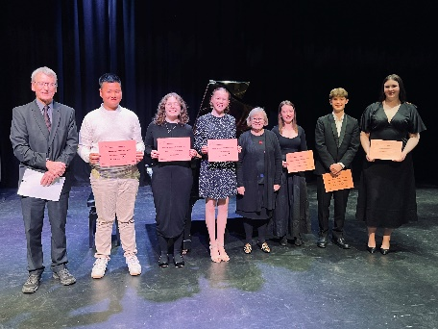

The President, Ms Kristine Mellens and the Committee of the Musical Society of Geelong Inc
have great pleasure in inviting you to our

60th ANNIVERSARY FUND RAISING DINNER

Friday 23rd May, 2025
6 pm

“TRUFFLEDUCK” 66 Hyland St, Fyansford

$75 per person

Includes a complimentary glass of champagne on arrival whilst some of our 2024 Scholarship winners (photo above) perform from 6-6.30pm.

This will be followed by a 2 course meal, tea and coffee.
All other beverages to be purchased.

There will be a Silent Auction and Main Auction to be led by Sean O’Brien from Ray White Highton. All monies raised will go to our Annual Scholarships.

After dinner we are thrilled and delighted to have special guest Peter Coleman-Wright join us for some recollections of his time in Geelong as a past Belmont High School student and winner of our Scholarships, and his stellar career since.

Please celebrate this auspicious occasion with us. Make up a table of 8-10 music-loving friends as this evening is for all interested persons and music-lovers. Or come along and we will place you with other music supporters. You are very welcome to attend and we hope to see you at this special event.

Bookings are essential – please complete the RSVP form on the attached page or on-line on our website by WEDNESDAY 14th MAY, 2025. For any enquiries please telephone 0407 392918 kemellens3@bigpond.com

If you are sadly unable to attend on the evening, but would like to support our work, please consider a donation of your ticket price, or any sum, and direct deposit into our account: details on RSVP form. The MSG Inc and the music students of Geelong will be very grateful.

The Musical Society of Geelong Inc, is an organisation which has run for 60 years, offering scholarships and performance opportunities for classical musical students in Geelong. It was started by COGG Councillors in 1965 and has operated since then, assisting many students to follow domestic and international careers in opera, symphony orchestras and as soloists, and also as eminent teachers. Our Patrons have included Dame Joan Hammond and George Logie-Smith. We have previously relied on donations from firms such as Alcoa, Ford, GAMA and others, and kind individuals. But times change and we have to adapt to how we fund raise: each year we award 5 scholarships of $1,500 each, after preliminary auditions and a public performance with adjudication.
We sincerely hope to see you at our dinner and help support the musical talent we have in Geelong.
Looking forward to the evening,
Kristine Mellens -President
  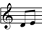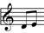

RSVP FORM: MSG Inc 60th ANNIVERSARY FUND RAISING DINNER

Please complete all details and return by post to the address below, or book through our website musicalsocietyofgeelong.org

with payment*** by Wednesday 14th May, 2025 to:
60th Anniversary Dinner c/- 5 Huntly Close, Highton 3216.

Name:___________________________________________________________
Address:__________________________________________________________

Telephone:_________________Email:__________________________________

Total number of tickets:___________@ $75 each = TOTAL amount paid of $_________

Names of guests at your table:

1.__________________________2._____________________________

3.__________________________4._____________________________

5.__________________________6._____________________________

7.__________________________8._____________________________

9.__________________________10.____________________________

DIETARY REQUIREMENTS: Gluten Free Vegan Vegetarian Lactose Free

(Please circle which is applicable and for which guest(s).) THANKYOU

***Bank details: Musical Society of Geelong BSB: 063523 Account no: 10116913

